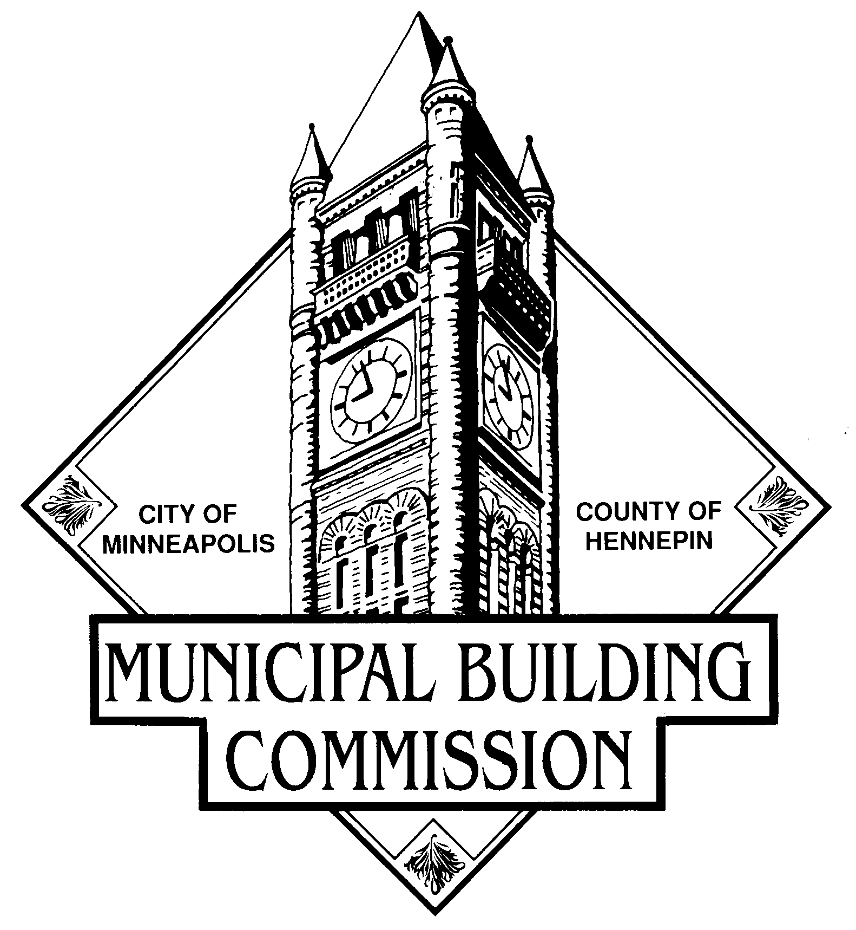
Minneapolis City Hall/Hennepin County Courthouse Rules
(As approved by the MBC Board on 9-22-2016)

Purpose:
The purpose of these rules is to guide conduct in the public space of the Minneapolis City Hall/Hennepin County Courthouse facility, to ensure that events held within the building are conducted in a manner that protects the health, safety, and security of occupants and building assets, allows for the orderly conduct of government business, while also ensuring public access and the public’s right to assemble.
For the purposes of these rules, public space is defined as that space within the Minneapolis City Hall/Hennepin County Courthouse facility and grounds that is not assigned to any department, including but not limited to:
- The 4th Street main rotunda area near the Father of Waters statue.
- Hallways, lobbies, plazas, stairwells, public restrooms, and common corridors.
- Council Chambers during official meetings.
These rules are in accordance with Minnesota Statute 624.72 subd. 3, and the Municipal Building Commission (MBC) 1970 Board Resolution, which authorizes the MBC to place reasonable rules on behaviors to ensure the public’s free and lawful access to these MBC controlled-spaces.

- The Minneapolis City Hall/Hennepin County Courthouse is a public building open Monday through Friday, 6:00 am- 6:00 pm (Except Holidays.)

- Use of public space is limited to safe and orderly activities that serve a legitimate public purpose.
- All public uses must comply with all applicable laws, rules and regulations. An individual or group may not interfere with city/county business, employees, clients or visitors, or obstruct the free flow of traffic. Interference includes generating disruptive noise and intimidating behavior.
- There is a separate policy for private events approved by the MBC.

What is Not Allowed by the Public at the Minneapolis City Hall/Hennepin County Courthouse:

- Conduct that violates Minneapolis City ordinance or Minnesota State law
- Storing unattended personal property, items or possessions
- Using alcohol or other controlled substances
- Driving or parking an automobile on the sidewalks
- Climbing on the statues, railings, staircase banisters or other building art
- Remaining in the building after closing
- Sleeping or camping
- Smoking
- Littering
- Possessing a dangerous weapon, ammunition or explosives
- Putting up tents, tarps or similar structures

- Affixing, draping, or holding posters, banners or any visual props on or over permanent structures including but not limited to balconies, rotunda railings, and balcony stairs
- The use of sticks or poles in the building
- The use of a bullhorn or other similar device used for sound amplification that is disruptive to the orderly conduct of business
- Gas, propane and charcoal grills; other open flame devices; fires; and flammable or explosive fuel generators
- Defacing the building or structure, including writing words or drawing with chalk or other materials
- All other conduct, equipment, or materials hazardous to public safety or that could result in damage to Minneapolis City Hall/Hennepin Courthouse property
- Per Minnesota Supreme Court ruling, photography in any courtroom or area where courtrooms are located without permission from the Court

